Library Management System: Mini-Project Report
Course: Object-Oriented Programming in Java, Lab 11 Prepared by: Machawira Tadiwanashe
(H250403B), Harare Institute of Technology] Date: 11 October 2026
1. Objectives
For this project we wanted to bring everything from Labs 1 to 10 together in one program: classes, inheritance, interfaces, exceptions, collections, streams and file handling. The result is a console Library Management System. A librarian can add books and DVDs, register members, lend and return items, see what is overdue and search the catalogue. Everything is saved when the program closes and loaded again the next time it starts.
2. System Overview
The program runs from a text menu. You pick an option, it asks for whatever details it needs, and then it prints the result or an error message. When you choose exit, it saves everything to CSV files, and the next run carries on from there.
The menu has nine options: add item, register member, borrow, return, list overdue items, search by title, list all items, list members, and save and exit.
3. Class Design
3.1 Class diagram
Figure 1 shows how the classes and the interface relate.
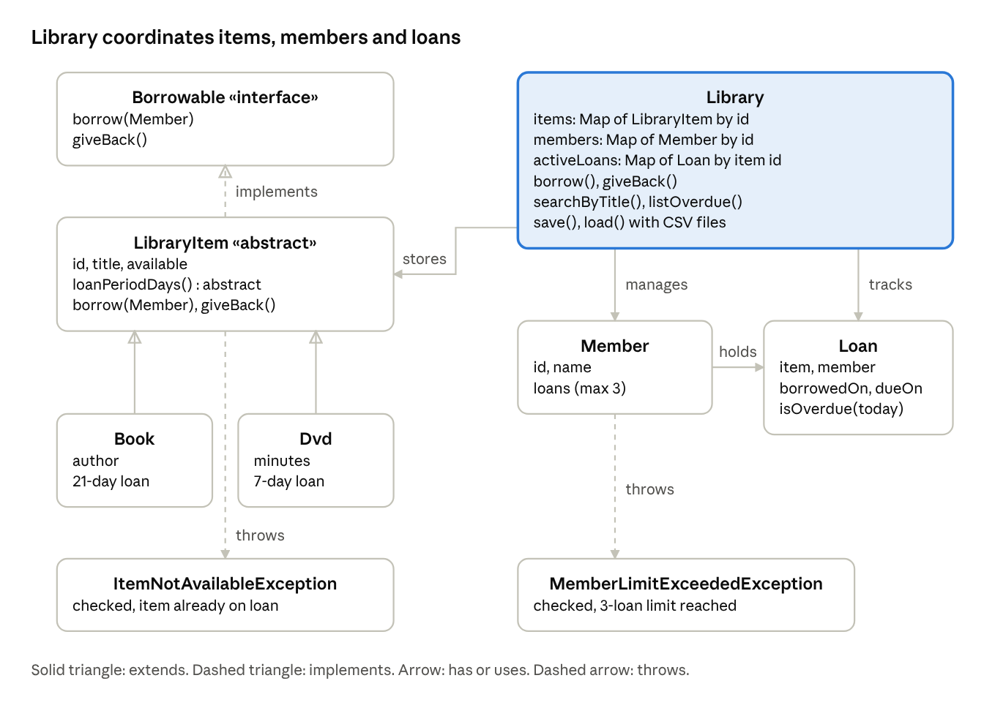
class diagram · 8 classes, 1 interface
Book and Dvd extend LibraryItem, which implements Borrowable. Library holds the items, members and loans, and the two exceptions are thrown when a borrow breaks a rule.
3.2 Classes and their responsibilities
Class / interface | Responsibility
Borrowable (interface) | Declares borrow(Member) and giveBack()
LibraryItem (abstract) | Shared state (id, title, availability) and borrow/return logic; declares abstract loanPeriodDays()
Book | Adds an author; loan period of 21 days
Dvd | Adds a running time in minutes; loan period of 7 days
Member | Holds id, name and active loans; enforces the limit of 3 loans
Loan | Links one item to one member with a borrow date and a due date; knows whether it is overdue
Library | Core service: owns the item, member and loan collections; borrow, return, search, overdue list, save and load
ItemNotAvailableException | Thrown when an item is already on loan
MemberLimitExceededException | Thrown when a member already has 3 loans
Csv | Small helper that reads and writes CSV lines safely (handles commas in titles)
LibraryApp | Console menu and user input handling
LibraryTest | Automated checks of the main behaviour
4. OOP Principles Demonstrated
Principle | Where it appears
Encapsulation | All fields are private. Constructors validate input (blank ids, empty titles, negative DVD length). Member.getLoans() returns an unmodifiable list, so no other class can bypass the loan limit.
Inheritance | Book and Dvd extend LibraryItem and reuse its id, title and borrow/return logic instead of duplicating it.
Abstraction | LibraryItem is abstract and declares loanPeriodDays() without an implementation, because a generic item has no loan period. Borrowable describes what can be borrowed without saying how.
Polymorphism | Library works with LibraryItem references. The call item.loanPeriodDays() returns 21 for a Book and 7 for a Dvd, decided at run time. This is what gives each loan its correct due date.
Programming to an interface | Collections are declared as Map and List. Items are referred to through LibraryItem and Borrowable.
5. Error Handling
We used two custom checked exceptions for the library rules. Because they are checked, the compiler makes every caller deal with them:
ItemNotAvailableException: raised by LibraryItem.borrow if the item is already on loan.
MemberLimitExceededException: raised when a member tries to borrow a fourth item.
Other mistakes, like an unknown member id, a duplicate id or letters typed where a number should be, throw IllegalArgumentException or IllegalStateException. The menu catches all of them, prints a short message and goes back to the menu, so bad input never crashes the program.
One detail worth pointing out: Library.borrow checks the member's loan limit before it marks the item as on loan. That way, if a borrow fails, the item is never left stuck as unavailable.
6. Collections and Streams
Items, members and active loans are stored in HashMap<String, ...> collections keyed by id, giving direct lookup by id.
searchByTitle uses a stream to filter items by a case-insensitive text match and sorts the results by title.
listOverdue uses a stream to filter loans whose due date is before today and sorts them by due date.
7. File Persistence
When you exit, the program writes three CSV files into a data/ folder:
File | Contents
items.csv | type, id, title, author or running time
members.csv | id, name
loans.csv | member id, item id, borrow date, due date
When it starts, Library.load rebuilds the objects from those files. Items that were on loan are marked unavailable again, and each loan goes back to its member with its original due date. The files are read and written with java.nio.file.Files. If there are no files yet, the program starts with an empty library. If a file is damaged, it prints an error and starts empty instead of crashing.
8. Testing
LibraryTest runs 15 checks without any outside framework (java LibraryTest). All 15 passed.
# | Test | Result
1 | Book loan period is 21 days | Pass
2 | DVD loan period is 7 days | Pass
3 | Borrowing an item already on loan throws ItemNotAvailableException | Pass
4 | A fourth loan throws MemberLimitExceededException | Pass
5 | A failed borrow leaves the item available | Pass
6 | Only the loan older than its period appears as overdue | Pass
7 | Unknown member id is rejected | Pass
8 | Negative DVD running time is rejected | Pass
9 | All items are reloaded from CSV | Pass
10 | A title containing a comma survives save and load | Pass
11 | Items on loan are unavailable after reload | Pass
12 | Overdue status survives reload | Pass
13 | The member's loan count survives reload | Pass
14 | Returning an item makes it available again | Pass
15 | Returning an item clears it from the overdue list | Pass
We also tried the menu by hand: registered a member, added a book, borrowed it, searched for it, exited, and then checked that the CSV files had been created properly.
9. Sample Output
[Insert screenshot: the main menu]
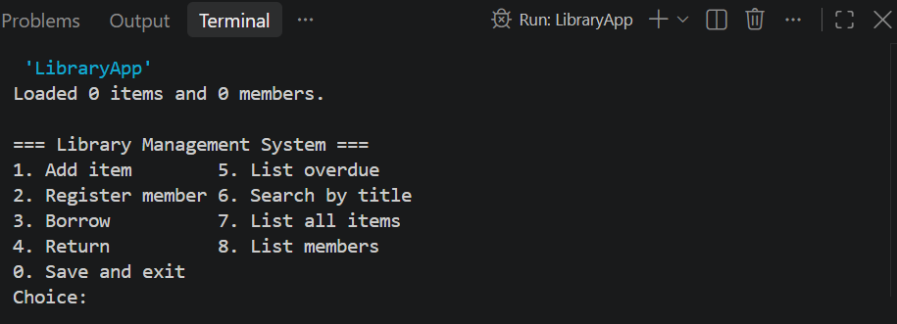
[ screenshot: borrowing an item successfully, with its due date]
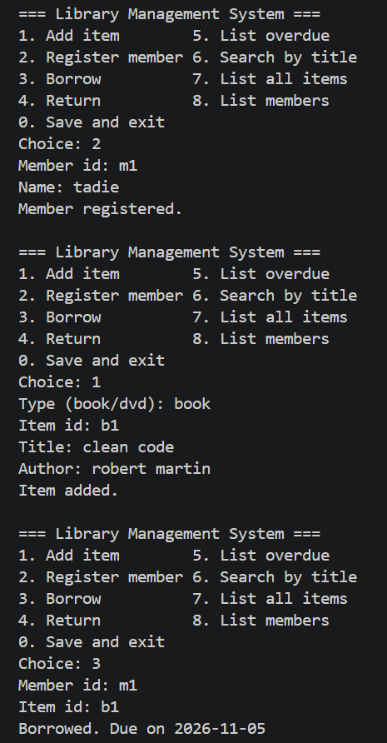
[ screenshot: trying to borrow an item that is already on loan]
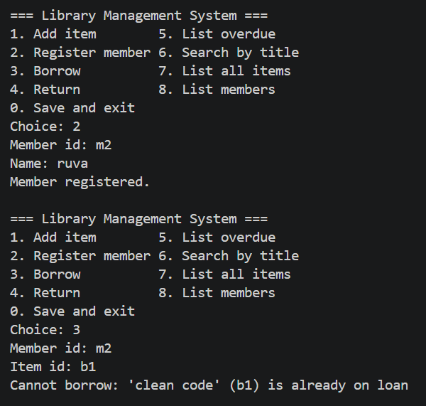
[screenshot: trying to borrow a fourth item]
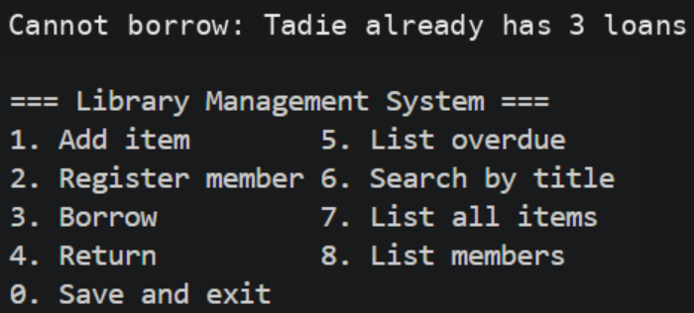
[screenshot: search by title and the overdue list]
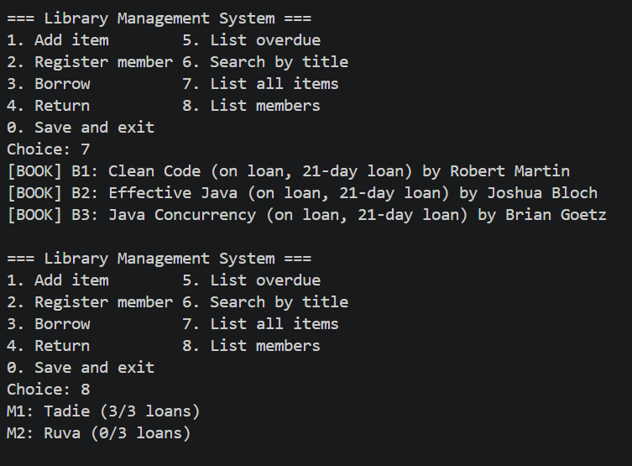
[ screenshot: the program restarted, showing the data was reloaded]
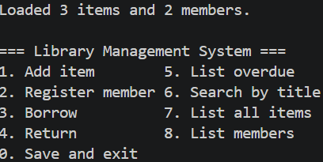
10. Conclusions
Working on this showed us how the four OOP ideas fit together. Abstraction and inheritance stop Book and Dvd from repeating the same code. Polymorphism lets the library treat every item the same way while each type gives its own loan period. Encapsulation keeps rules like the three-loan limit from being skipped. The custom exceptions make those rules clear, collections and streams keep lookups short, and the CSV files mean the data survives between runs.
With more time we would add fines for overdue items, a return history, member search and a graphical interface, and we would replace the CSV files with a database.
Appendix: Source Files
Borrowable.java, LibraryItem.java, Book.java, Dvd.java, Member.java, Loan.java, Library.java, Csv.java, ItemNotAvailableException.java, MemberLimitExceededException.java, LibraryApp.java, LibraryTest.java

